**Leader Overview**

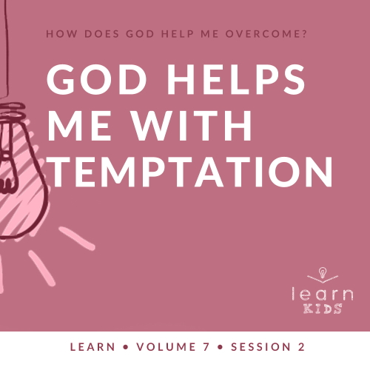

**Volume Overview**

**How does God help me overcome?**

*Life can be full of challenges. Thankfully, when we make the decision to live for God, we can have confidence that we’re no longer walking through life alone. God offers His help to us throughout every difficult circumstance. He knows that we’ll face fears, decisions, and emotions that we don’t feel equipped to handle. When we don’t know what to do, we can turn to God for the answer. He will help us overcome every challenge.*

**Session Overview**

**God Helps Me with Temptation**

*The Bible tells us that we’re sinful people. We’ve all messed up and given in to the temptation to make bad choices. The Bible also tells us that this isn’t how God wants us to live. God can give us the strength to make good choices even when it’s difficult to do so. In our Bible story, life was actually going pretty well for Joseph when he was tempted to make a bad choice. Even though he resisted, he still faced some bad consequences, but God was with him.*

**Bible Lesson**

Joseph and Potiphar’s Wife

[Genesis 39:1–23](https://ref.ly/logosref/Bible.Ge39.1-23)

**Faith Fact**

God helps me make good choices.

**Faith Verse**

[Philippians 4:13](https://ref.ly/logosref/Bible.Php4.13) (NLT)

For I can do everything through Christ, who gives me strength.

**Preparing for the Session**

**Leader Preparation Time: 20–25 Minutes**

|  |
| --- |
| ***You Will Need***  ***Large Group***   * *Bible* * *Worship songs (Song suggestions: “Nothing Is Impossible” by Planetshakers; “Won’t Let Go” by Gateway Kids Worship; “Overcome” by Elevation Worship; “Holy Ground” by Passion)* * *For groups not using a phone or tablet only, add:*   *• Projector or TV*  *• Laptop*  *•* ***Faith Fact Slide***  *•* ***Faith Verse Video*** *or* ***Slide***  *•* ***Bible Lesson Video***  *•* ***Teaching Point Slides 1–3***  *• Cell phone with a map app*  *• School textbook or homework worksheet*  ***Small Group***   * *Marshmallows or another treat, two per kid* * *Bibles for kids in your group to share* * ***Small Group Activity Page****, one per kid* * *Pencils or pens, one per kid* * *Crayons or markers*   *To access session content and videos from a computer, visit:* [*BibleEngagementProject.com/downloads*](https://bibleengagementproject.com/downloads) |
| ***Getting Ready***  ***Large Group***   * *Download videos and slides if needed.* * *Select worship song(s) and have them ready to play.* * *Read the Bible Lesson Scripture to prepare for Teaching Time.*   ***Small Group***   * *Recruit an extra adult leader for Group Connection. Decide if the other leader should try to tempt the kids to not follow your instruction.* * *Give them instructions for the activity while you’re away from the group.* * *Print copies of the* ***Small Group Activity Page****, one per kid.*   *First time leading* Learn *for Kids? Check out the* [*Facilitator Guide*](https://0b769b0ed3569ef9d18b-f88d8272f61086866d50d048b43ef630.ssl.cf2.rackcdn.com/sites/biblengagementproject/Listen_Facilitator_Guide.pdf)*.* |

**Large Group**

**30 Minutes**

*See what’s needed at the beginning of the session.*

**Introduction**

Hello, everyone! I’m so excited that you’re here. Today we’ll learn that God helps us make good choices. There are many times in our life when we’re tempted to do things that we know are wrong.

Temptation is having the chance to do something wrong and wanting to do it. For example, maybe your parents told you not to use their phone if they aren’t with you. But one day you see your mom’s phone in the kitchen, and you know she’s busy in another room. You want to use her phone, even though you know you shouldn’t.

That’s what it means to be tempted. Raise your hand if you’ve ever been tempted to do something wrong like that. *(Group response)* Everyone has been tempted to do wrong.

• *Tell a personal story about a time you faced temptation. Try to keep it light and applicable to kids if possible.*

• *If you can’t think of a personal story immediately, tell a story about a kid being tempted to take a warm cookie fresh out of the oven after her mom told her to wait until after dinner to eat a cookie. It’s a simple illustration that kids can relate to.*

**Faith Fact**

Every person is tempted to do something wrong at times. In fact, we can be tempted pretty much every day. God knows that what we’re tempted to do isn’t good for us. He doesn’t want us to fall for it. That’s why our Faith Fact today is **God helps me make good choices**.

• *Show the* ***Faith Fact Slide.***

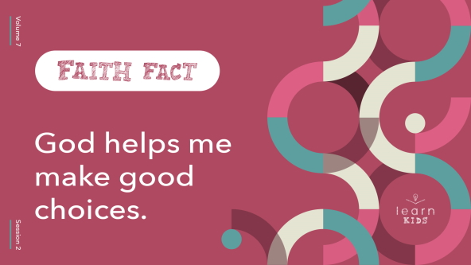

This is one of the most important things you need to remember today. Everyone, get up and find someone who’s wearing something that matches a color you’re wearing. Then, say the Faith Fact to that person. **God helps me make good choices.**

• *Give kids time to respond.*

Great job, everyone! Come back to your seat. Let’s say the Faith Fact together one more time. **God helps me make good choices.** Great job!

**Game**

**Preferences**

We make choices every day. Some are good and some are bad. Some choices are just preferences. For example, the flavor of ice cream you like isn’t a good or bad choice; it’s a preference. A preference is something that you would choose instead of something else. We’re going to play a game called Preferences. I’ll call out a choice that you could make.

• *Adapt the following instructions if kids can’t run across the room.*

If you prefer the first option, then go to the left side of the room. If you prefer the second option, go to the right side of the room. Then, come back to the middle of the room between each preference. Let’s get started.

• *Read the following preferences and allow time for kids to respond:*

• Ice cream or snow cones?

• Cookies or brownies?

• At a movie, popcorn or candy?

• McDonalds or Chick-fil-A?

• On vacation, mountains or the beach?

• Bicycle or skateboard?

• Bowling or mini golf?

• Video games or playing outside?

• Hamburgers or hot dogs?

• Cats or dogs?

• *Consider inviting kids to come up with their own to suggest for the group to choose from.*

Every one of you has some unique preferences. Though you might not agree with someone else’s choice, that doesn’t mean theirs is wrong. Sometimes though, we can be tempted to choose things that are wrong, and we make bad choices. For example, if I don’t have time to get my homework done, so I choose between getting a bad grade or copying someone else’s work. In moments like that, we can ask God to help us make the right choice.

**Worship**

God not only want us to do what’s best for us but He’ll also help us do those things. We can show thanks and honor to God for that through our worship. Who’s ready to worship God today? *(Group response)* One way to worship God is by singing. Let’s worship Him together.

• *Lead the kids in singing one or two praise songs. See suggestions at the beginning of the session.*

**Bible Lesson**

I’m so thankful for God’s help when we need it, aren’t you? *(Group response)* That was an incredible time of worshipping God by singing together. Now, it’s time to learn from God’s Word. Today, we’ll find out more about Joseph. In today’s Bible story, he had to make a choice when he was tempted. One choice was really good, but would actually get him in trouble. The other choice was really bad, but for a moment, it could have made life easier. The way Joseph handled this situation can teach us a lot about what we should do when we’re tempted.

**Prayer**

|  |
| --- |
| *Dear God, thank You for Your Word and how it teaches us that You’re with us when we have to make hard choices. Help us to learn more about who You are and how You help us. Amen.* |

**Video Intro**

Before we look at the Bible story, let’s watch this video.

• *Play* ***Bible Lesson Video****.*

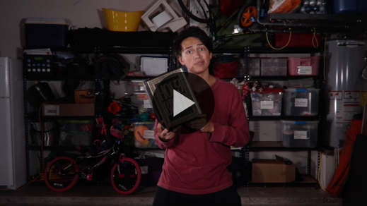

**Bible Story**

**Joseph and Potiphar’s Wife**

That video was such a fun lead-in to our Bible story today! We talked about temptation earlier. Has anyone here ever been tempted to do something wrong? Maybe it was to take an extra piece of candy or a treat that you knew you shouldn’t have. Maybe it was to take a toy or money that belonged to someone else because you thought they wouldn’t notice. Maybe your friend wanted you to watch a video that you knew you shouldn’t watch. Those are all temptations. What are other temptations that people face? *(Allow responses.)*

We all face choices like these throughout our life, and we need to be ready to say no to temptation when it shows up. Let’s see what Joseph’s life can teach us about how to handle temptation. Grab your Bible or pull up a Bible app on your device. Turn to [Genesis 39:1–23](https://ref.ly/logosref/Bible.Ge39.1-23).

• *Read the Bible story aloud to the group.*

• *In order to keep Large Group time moving along, we don’t recommend having the kids read.*

• *Optional: Remind the kids to mark this place with their Bible Bookmark, so they can read it on their own at home.*

**Teaching Time**

|  |
| --- |
| ***You Will Need***   * ***Teaching Point Slides 1–3*** * *Cell phone with a map app* * *School textbook or homework worksheet.*   *No prep needed for this activity.* |

Could you imagine being Joseph in this situation? He was given the chance to do something very wrong. He might have been tempted to do it, but he wanted to honor God. God was with Joseph and helped him overcome this temptation. Joseph stayed strong, but that choice to do what was right put him in prison. What? He did the right thing. Why did he go to jail? Does that make any sense? *(Group response)* It doesn’t seem to, at least not right now.

I think we can learn a lot about how to make good choices from the story we just read. Joseph’s story also reminds us that we need God’s help. That’s why our Faith Fact is so important. Say it with me. **God helps me make good choices**. Say that with me again as loudly as you can. **God helps me make good choices**. Here are three things to remember when we’re feeling tempted.

**1. Everyone is tempted to make bad choices.**

• *Show the* ***Teaching Point 1 Slide.***

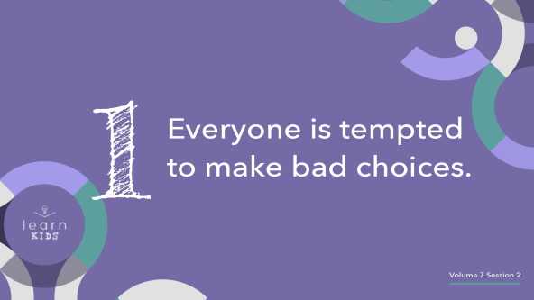

No two people are exactly the same. Even identical twins look a tiny bit different, and they definitely have unique personalities. We know we all have different preferences, and we like some things better than others. All those things work together to help us be unique people. Even so, there are some things that happen to everybody.

Let’s think of a few. Everyone breathes air. Can’t get around that one. Everyone needs healthy food and water to survive. Can’t get around that one either. Can anyone else think of something that’s common to every single person? *(Allow responses.)* Here’s another thing that will happen to everyone no matter what. We’ll all be tempted to do wrong.

In our Preferences game, imagine that you were the only person who chose snow cones when the choice was ice cream or snow cones. That might make you a little lonely, right? *(Group response)* It’s good to know that we’re never completely alone. God is always with us. Though temptation is a bad thing that we all face, it might encourage you to know that you aren’t the only one who faces it. Every person on the planet gets tempted.

When we know that everyone faces temptation, we can start preparing for the next time it shows up. I think all of us want to make the good choices that God wants us to make. But, it can be hard in the moment to choose the right thing and then follow through. The best time to prepare for making the right decision when we’re tempted is now. But how do we do it? Our Faith Fact tells us how. **God helps me make good choices**.

**2. God helps us make good choices.**

• *Show the* ***Teaching Point 2 Slide.***

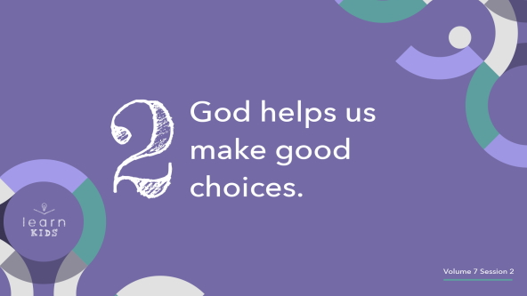

If we give in to temptation and make the wrong decision, we might want to make excuses. It can sometimes feel like we didn’t have a choice, like we were helpless, or like we couldn’t control ourself. It’s great for us that when we feel this helpless and lost, we have someone who can give us a way out: God.

Who has been hiking before? *(Group response)* Imagine that you were hiking all by yourself in a forest. Then you got lost because you wandered off the trail. You knew that you should have stayed on the path, but you wanted to go and explore something else. Before you knew it, you were lost. What would you do in that hopeless situation? *(Allow responses.)*

• *Hold up a cell phone with a map app showing.*

Well, if you came prepared for your hike and brought a phone with a GPS or a map in case you got lost, you have that to help you find your way.

Life is like that, too. God’s Word is like a map for us when we’re trying to make decisions. The Bible shows us the way to make good choices. God also helps us to know which choices we need to avoid. God guides us by His Word and the Holy Spirit. Without God’s guidance, we can feel lost.

In the times when we are tempted, we can ask God to help us. There’s an awesome Bible verse, [1 Corinthians 10:13](https://ref.ly/logosref/Bible.1Co10.13), that tells us whenever we’re tempted, God will show us a way out. Knowing that can help us feel better about facing temptation. It’s going to come, but God will help us make the right choices.

**3. Keep making good choices, even if there are bad consequences.**

• *Show the* ***Teaching Point 3 Slide.***

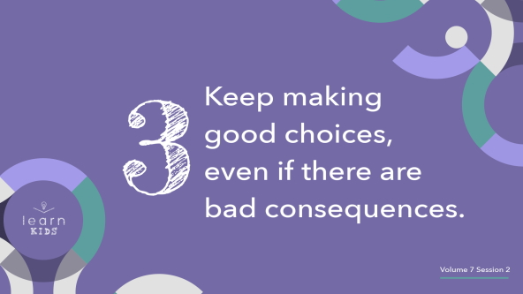

Making the right choice means we’ll never have problems, right? *(Group response.)* No, of course not! We saw in our Bible story today that Joseph made the right choice and didn’t give in to temptation. Then, he was punished like he had done the wrong thing. That probably doesn’t make sense, does it? That’s just how it is sometimes. Even when you do the right thing, bad things can still happen. No matter how bad it is, God can help you through it. God helped Joseph, and He will help you.

We’ll talk more in our small groups about good decisions we can make that actually may have consequences in our life that seem bad. Here’s a really easy one.

• *Hold up the textbook or homework worksheet.*

How many of you are ever tempted not to do your homework? *(Group response)* It can be so easy to look at the work we’re supposed to do and think, *“Oh, I don’t need to do that. I can skip it or get the answers from my friends.”* Sometimes doing the homework, which is the right choice, can feel like punishment when there’s something else you’d rather be doing. However, we know it’s the right choice.

Unfortunately, not every choice is that simple. That why we need God’s help. If we pray and ask God for guidance, we can know whether choices are right or wrong. He might share the right choice through a Bible verse. He might use a parent or leader to help you know. He could also help by bringing the right choice to your mind. God can help us in many ways.

At some point, we’re all going to be tempted to make the wrong choice, especially if the right choice seems to have bad consequences. Like Joseph, we should always make the right choice, no matter what. God will help us do it.

**Prayer and Response**

*Consider playing a worship song softly in the background while kids pray.*

Everyone faces temptation. It might be a choice about lying, stealing, taking too much of something, or anything else that we want to do but know we shouldn’t. Thankfully, God wants to help us make the right choice when we’re tempted.

Let’s take time to pray and ask God to help us when we’re tempted. We can be tempted to think, look at, say, believe, and do things that are wrong. As I pray for help in all these areas, I want you to put your hands on the parts of the body I mention: mind (head), eyes, mouth, heart, and hands. Let’s ask God to help us when we’re tempted to do wrong.

**Prayer**

• *Optional: Have the kids repeat phrases of the prayer after you.*

|  |
| --- |
| Dear God, please help my mind think thoughts that honor only You. Please help my eyes look at things that are good. Please help my mouth say words that encourage and lift up others and not hurt them. Please help my heart believe what Your Word says. Please help my hands do what You ask me to do. Help me when I’m tempted and show me how I can make the right choice. Amen. |

**Faith Verse**

Our Faith Verse reminds us that Jesus gives us strength to do anything, including making the right choice when we’re tempted. Let’s say our Faith Verse and do the actions together.

• *Play* ***Faith Verse Video****.*

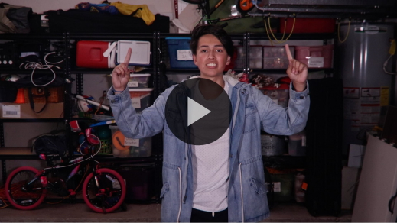

[Philippians 4:13](https://ref.ly/logosref/Bible.Php4.13) (NLT)

For I can do everything through Christ, who gives me strength.

Remember, when we’re tempted, Jesus gives us strength to do the right thing. He is always with us and helps us overcome life’s temptations.

**Faith Fact**

Before we go to our small groups, let’s review our Faith Fact again.

• *Show the* ***Faith Fact Slide****.*



Say it with me. **God helps me make good choices.** Remember, God helps us to make good choices. It’s not something we have to do alone. Even if it seems like the right choice has bad consequences, the right choice will pay off in the end.

• *Dismiss kids to Small Group time or to go home if your group time ends here.*

**Small Group**

**30 Minutes**

*This section can be done in conjunction with the large group or on its own if you do small groups with your kids. During Small Group time, the goal is to connect the kids with the Word of God and to each other. All activities are led by the small group leader.*

**Group Connection**

**Treat Temptation**

|  |
| --- |
| ***You Will Need***   * *Marshmallows or another treat, two per kid*   ***Getting Ready***   * *You will need an extra adult leader for this activity. Decide if the other leader should try to tempt the kids to not follow your instruction.* * *Give them instructions for the activity while you’re away from the group.* |

I’m so excited that we get to spend some time together today. In fact, that’s why I brought a treat for all of you. Before we get started, I’m going to pass out a treat to each of you.

• *Pass out a single treat to each kid.*

Oh no! I forgot something. *(I need to take a phone call, etc.)* Let me take care of it. I’ll be right back. Don’t eat your treat yet.

• *Leave the group for a minute or two.*

• *Optional: The other leader can deliberate with the kids on whether or not they should eat their treats.*

Okay, I’m back. Now, everyone, hold out your treat. Wait, did anyone eat it already? *(Group response)* I know it might have been tempting, so I have a second treat for anyone who listened to my instructions and waited.

• *Pass out a second treat to kids who didn’t eat the first one while you were gone.*

Now, why do you think we just did that activity? *(Allow responses.)* Today, we’re talking about temptation and God helping us make good choices. In this situation, eating the treat before I came back gave you a delicious snack right away. It also meant giving in to temptation and losing out on the second treat.

Resisting temptation paid off. Some of you got double treats. Sometimes we don’t see the reward right away. That’s why self-control is a very important thing for us to practice. Joseph didn’t get a reward right away. In fact, he was punished. However, over time we can often see why it’s important to make good decisions along the way. We’ll find out that this was true for Joseph.

**Learn about It**

|  |
| --- |
| ***You Will Need***   * *Bibles for kids in your group to share*   *No prep needed for this activity.* |

**Scripture Search:** [**Matthew 6:13**](https://ref.ly/logosref/Bible.Mt6.13)**;** [**1 Corinthians 10:13**](https://ref.ly/logosref/Bible.1Co10.13)**;** [**2 Timothy 2:15–16**](https://ref.ly/logosref/Bible.2Ti2.15-16)**;** [**Matthew 4:1–11**](https://ref.ly/logosref/Bible.Mt4.1-11)**;** [**Hebrews 4:15**](https://ref.ly/logosref/Bible.Heb4.15)

Let’s dig deeper into God’s Word and see what else He has to say to us. As we find and read each of these verses, let’s consider: What does this Scripture mean for our life today?

• *Give each kid a Bible and search for one or more of the Scriptures as a group together (as time allows). When everyone has found the Scripture, have one of the kids read it. Then, answer the questions about it.*

• *Pair kids who need additional help with older kids or start simple and look up the session’s Bible story Scripture:* [*Genesis 39:1–23*](https://ref.ly/logosref/Bible.Ge39.1-23)*. Kids will get better at finding Scriptures the more they practice.*

• *Optional: Make this a competition to see who can find the Scripture first.*

**Bible Reading Tip**

Do you ever have extra minutes in your day when you’re at home, school, or even riding in the car? *(Group response)* One thing you can do with that extra time is read the Bible. God will use the time we give Him to speak to us through His Word.

**Challenge**

We can be ready to spend time with Him by having God’s Word with us. Here’s a challenge for you. Take your Bible with you as much as you can every day this week. When you have some extra time, open up the Bible and read it.

If you find yourself in a tempting situation this week, open your Bible to our Faith Verse, [Philippians 4:13](https://ref.ly/logosref/Bible.Php4.13), or read about the story of Joseph’s temptation in [Genesis 39](https://ref.ly/logosref/Bible.Ge39). By reviewing how Joseph ran from temptation, you can remind yourself that it’s always worth it to make the right choice. God will help you do what’s right.

**Faith Fact**

God’s Word is one of the best things God uses to help us make the right decisions. That reminds me of our Faith Fact. **God helps me make good choices.** Say it with me. **God helps me make good choices.**

**Group Discussion**

*Feel free to use all or just a few questions as a jumping-off place for good discussion. Questions marked with * are designed for more conversation. Adjust the questions based on the age or maturity of your group. Typically, older kids will be able to dive a little deeper than younger ones.*

**Questions**

• *If small group activities are not immediately following large group time, you may want to read the Bible story passage before this discussion.*

Joseph was a servant in whose house?

What happened to Joseph after he did the right thing and avoided temptation?

* What stuck out to you the most about this story?

* Why are we tempted to make bad choices?

In what ways does God help us make good choices?

* What’s an example of a good choice we can make that might have consequences that seem bad?

Do you think it’s worth it to always do the right thing? Why?

* When is it hardest for you to do the right thing?

How can we tell when something is right or wrong?

How might your life be different if you asked God to help you make good choices?

**Prayer Requests**

*Finish group discussion by sharing prayer requests and praise reports. Keep track of your small group’s prayer requests and review them each time you meet.*

**Prayer**

*Have kids pray for each other’s prayer requests.*

**Faith Verse Review**

Our Faith Verse is [Philippians 4:13](https://ref.ly/logosref/Bible.Php4.13). This verse reminds us how we can have strength to make good choices. Let’s review it now.

• *Show* ***Faith Verse Video****.*



[Philippians 4:13](https://ref.ly/logosref/Bible.Php4.13) (NLT)

For I can do everything through Christ, who gives me strength.

In the moment that you feel tempted to do wrong, say this verse to remind yourself that God can help you do right. Let’s review our Faith Verse as a group a couple of more times. Try to memorize it as best as you can because you will need to know it for the Faith Verse game.

• *Say the verse as a group a couple times.*

**Faith Verse Fun**

**Gotcha!**

This verse is very encouraging when we face temptation, so let’s try to keep it in our head and in our heart with a game. I’ll say the verse, but I’m going to leave out or change a word or phrase. If you catch me, say, “Gotcha!” If you’re right, you get to lead the next round. Let’s play.

[Philippians 3:14](https://ref.ly/logosref/Bible.Php3.14) (NLT)

For I can do everything through Christ, who gives me strength.

[Philippians 4:13](https://ref.ly/logosref/Bible.Php4.13) (NLT)

For I can do everything **in** Christ, who gives **people** strength.

[Philippians 4:13](https://ref.ly/logosref/Bible.Php4.13) (NLT)

For I can do everything through **Jesus**, who gives me **power**.

• *Give the kids an opportunity to change up the verse.*

Great job, everyone! Remember to say this verse when you’re facing temptation. God wants to help us with anything we’re facing.

**Activity Page**

**Facing My Distractions**

|  |
| --- |
| ***You Will Need***  *•* ***Small Group Activity Page****, one per kid*  *• Pencils or pens, one per kid*  *• Crayons or markers*  ***Getting Ready***  *• Print copies of the* ***Small Group Activity Page****, one per kid.* |

When we have a goal that we need to accomplish, we can let other things tempt us from finishing the task. For example, your goal may be doing your homework. What tempts or distracts you from getting it done? *(Allow responses.)* Those are good answers.

• *Give a copy of the* ***Small Group Activity Page*** *and a pencil to each kid.*

On your Activity Page today, look at each picture and write the temptation each kid needs to overcome. Then, color the pictures.

• *Allow time for the kids to complete the page.*

No matter what temptations we face, we can be sure that God will help us to make the right choices.

**Dismissal**

Remember, everyone is tempted, but God is ready to help us when we’re tempted. You aren’t alone. God will show you how to make right choices. Even if there are some consequences that seem bad at the beginning, stick with God’s plan like Joseph did. When we make the right choice, we can show others God is working in our heart. We can help them see what it looks like to follow Jesus. Let’s close in prayer.

**Prayer**

|  |
| --- |
| *Dear God, thank You for helping us make good choices. You know what’s best for us. We trust that You’ll lead us through temptation to do what honors You. Help us to show Your love to the world around us. Amen.* |

**Faith Fact Recap**

• *Show the* ***Faith Fact Slide****.*



I’m so glad that we learned this powerful truth together today. One important thing I want you to remember is our Faith Fact. Let’s say it together one more time. **God helps me make good choices.** I’m really glad you came today. I can’t wait to see you next time**.**

• *Send home the* ***Small Group Activity Page.***

• *Remind parents that there are* ***Family Devotions*** *available on the app to do with their kid.*

• *Tell everyone the date and time for the next session*.